**Final Assessment**

**MCQs:**

1. What does WSL stand for in the context of Windows?

**Answer**: Windows Subsystem for Linux

1. What is the primary goal of continuous integration (CI) in DevOps?

**Answer:** Frequent Integration of Code Changes

1. In the Linux command line, what does the cd command do?

**Answer:** Change the Working Directory

1. Which of the following is not a Linux distribution?

**Answer:** Docker

1. What is Docker primarily used for in DevOps and containerization?

**Answer:** Packaging and Deploying applications in containers

1. What is the primary purpose of Azure DevOps?

**Answer:** Software Development and Delivery

1. Which components are part of Azure DevOps?

**Answer:** Azure Boards and Azure Pipelines

1. How does Azure DevOps support version control in software development?

**Answer:** It tracks changes in source code and manage versions

1. In Linux, what is the primary role of the root user?

**Answer:** Administrative tasks with superusers privileges

10. In Azure DevOps, which component is used to define, build, test, and deploy applications?

**Answer:** Azure Pipelines

**LABs:**

1. 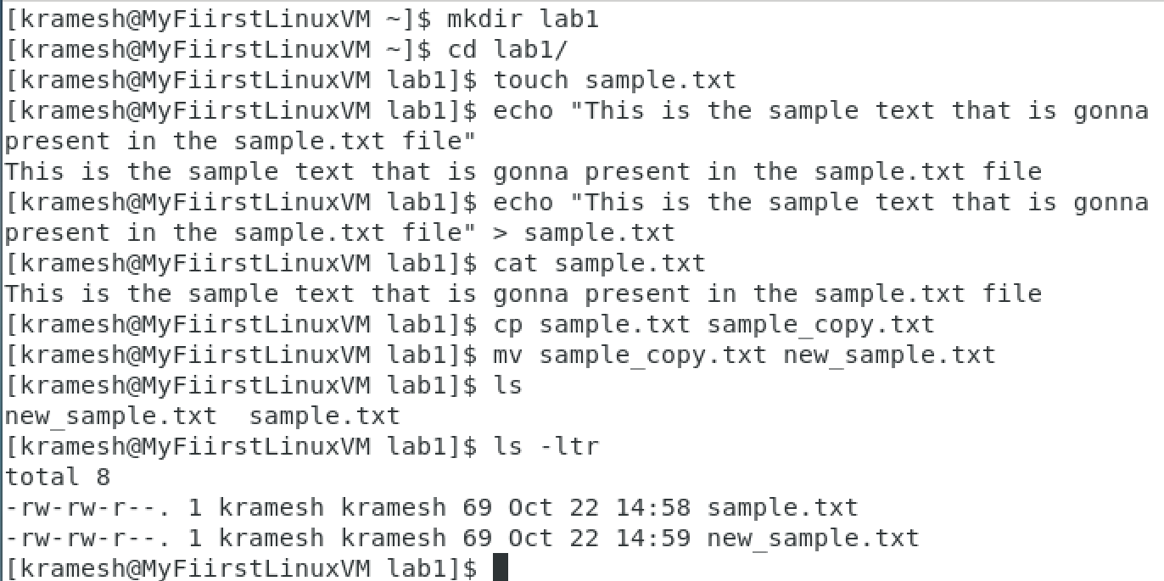**File and Directory Management**
2. 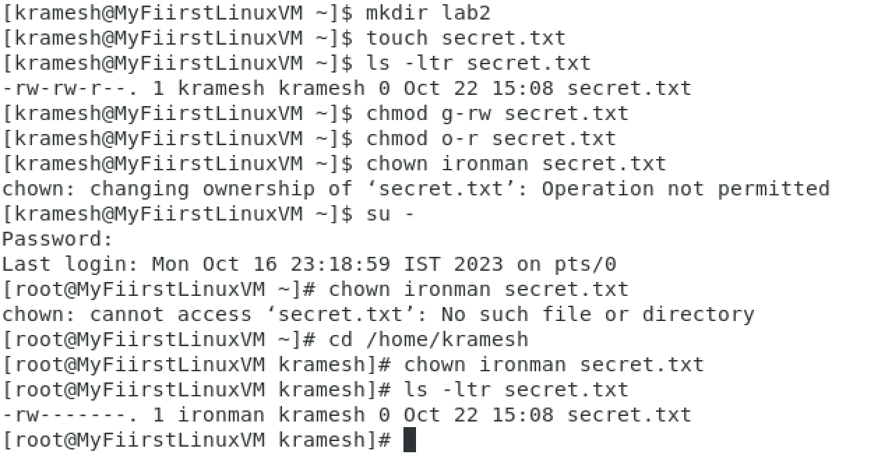**Permissions and Ownership**
3. 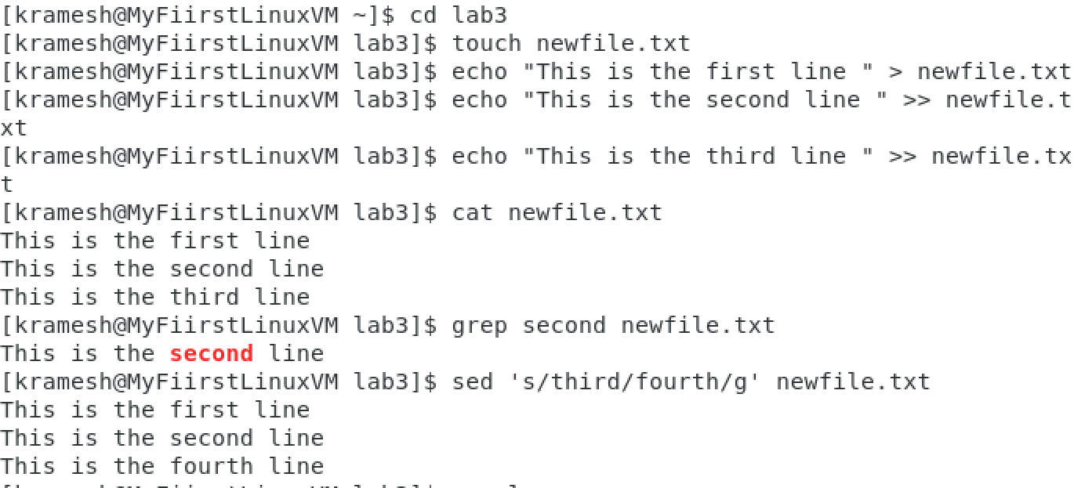**Text Processing with command line tools**

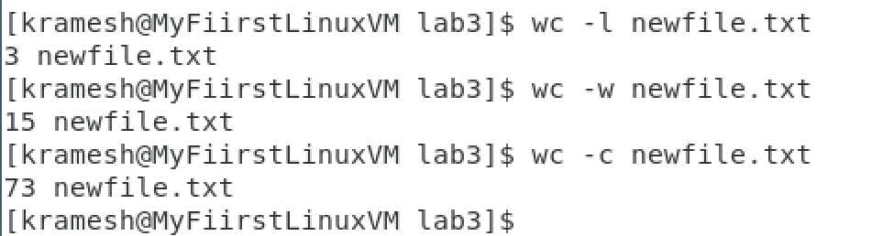Line counts, Words count and Character Counts in the newfile.txt

1. 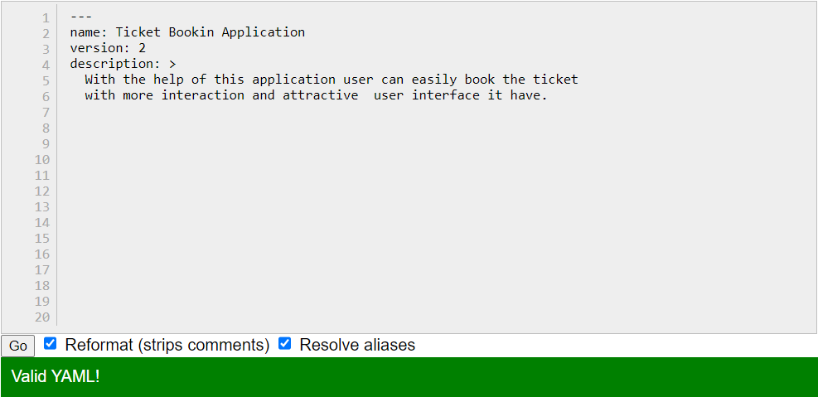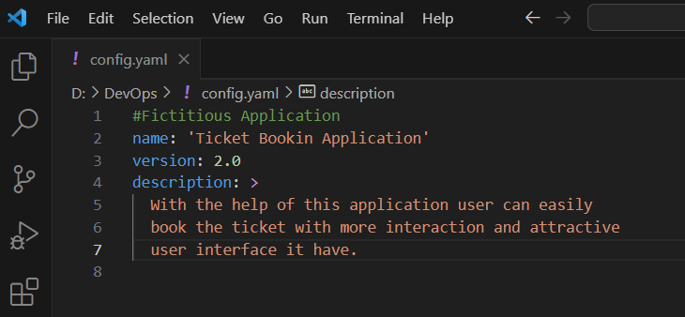**Creating a Simple YAML file**
2. **Working with lists in YAML**

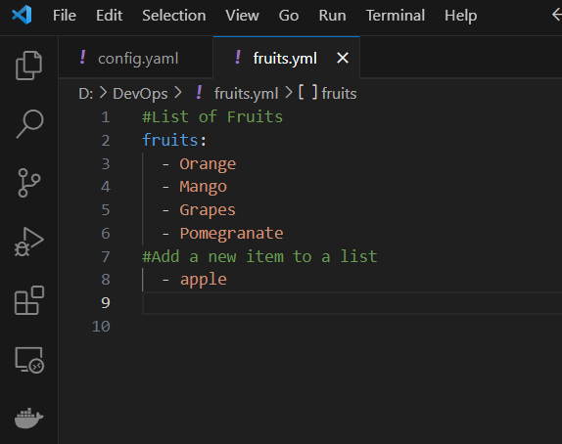

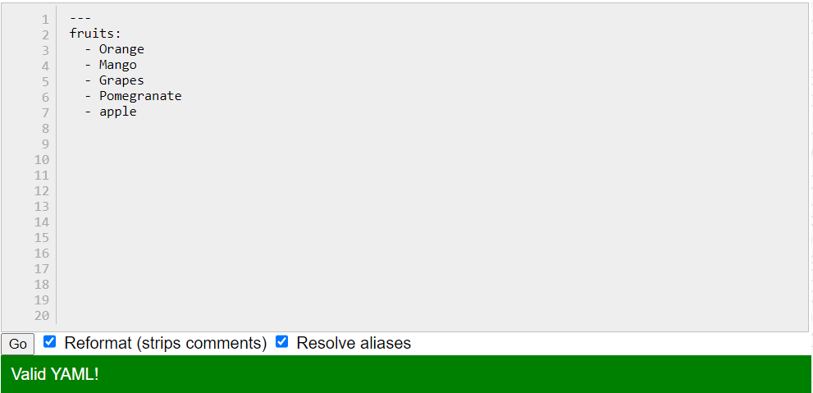

1. **Nested Structures in YAML**

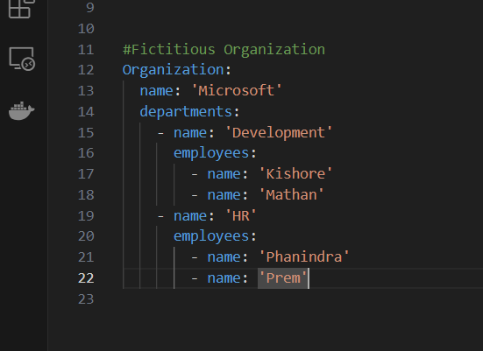

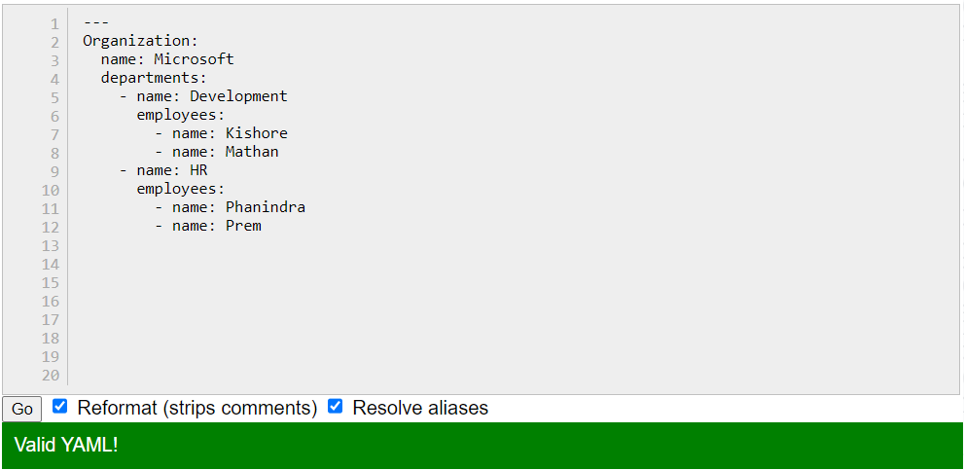

1. 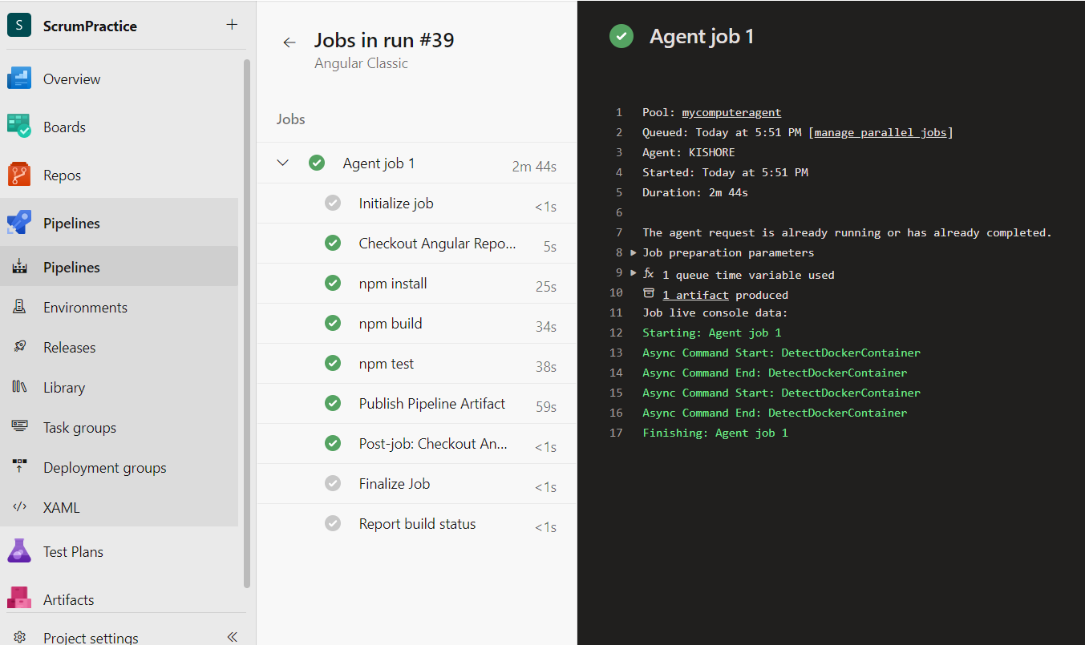**Classic Azure Pipeline for Angular Application**

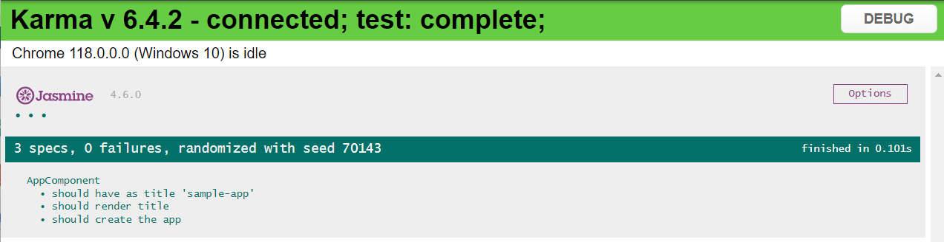

1. 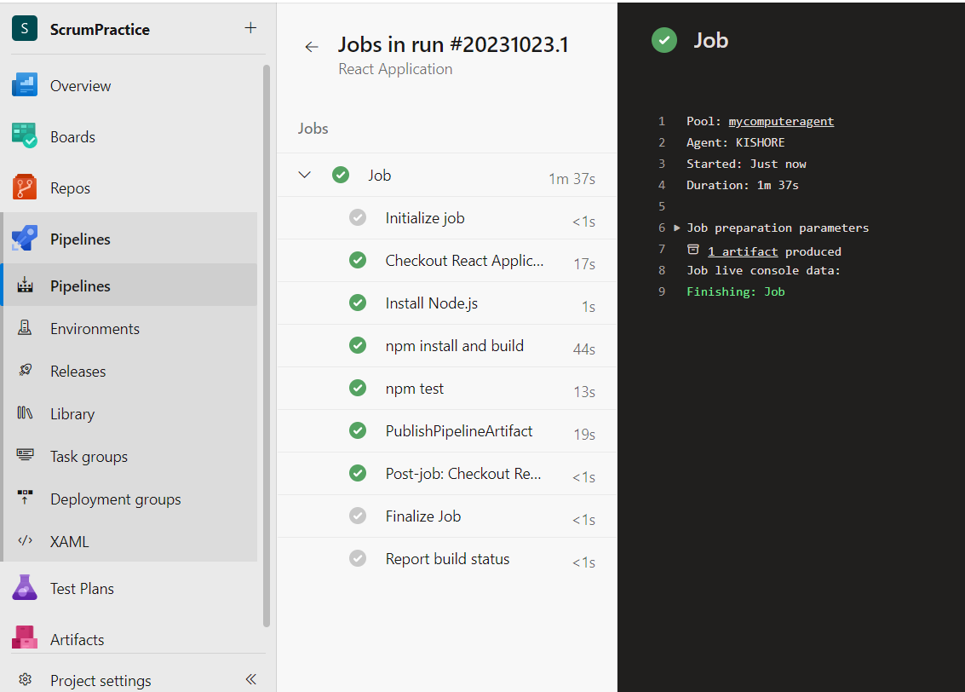**YAML Azure Pipeline for React Application**
2. 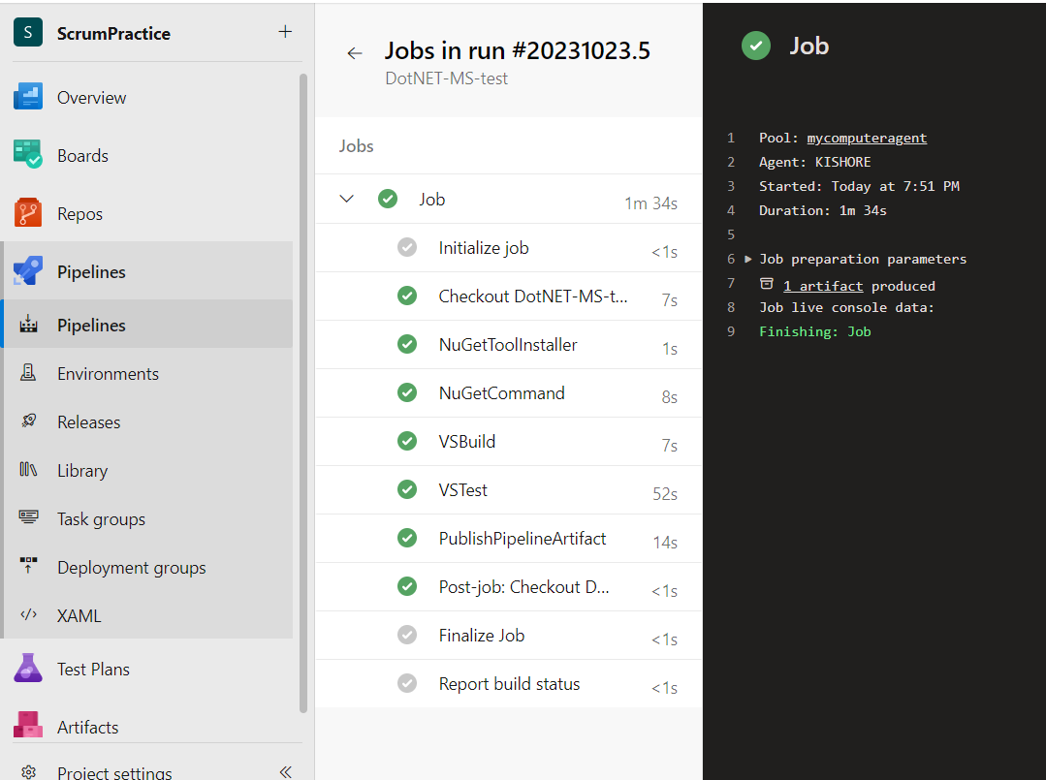**CI pipeline for .NET application with MS unit test**
3. 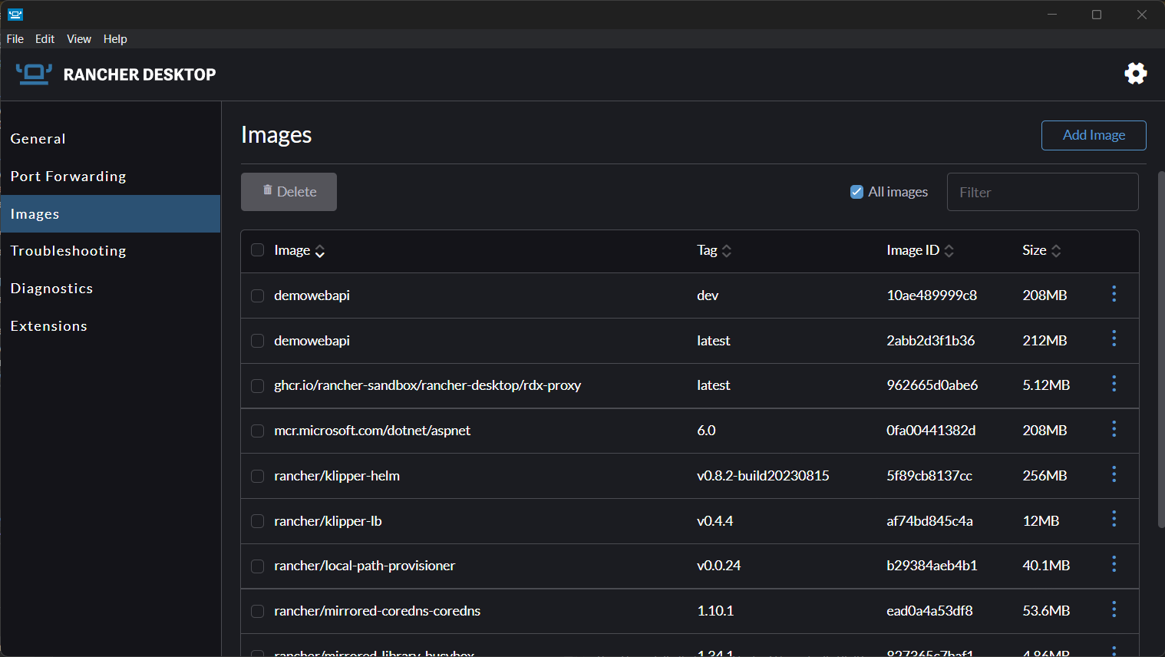**Docker Image for ASP.NET core and run it on Rancher Desktop**

